SKIN CANCER

*By:-Sai Varshitha Venigalla*

# Abstract :

Skin cancer is the most common type of cancer worldwide. It is mainly divided into melanoma and nonmelanoma skin cancers. Nonmelanoma skin cancers include basal cell carcinoma and squamous cell carcinoma. Having fair skin and being exposed to ultraviolet B (UVB) rays from the sun or tanning beds are the biggest risk factors. The best way to prevent skin cancer is to avoid sun exposure and not use tanning beds.

# Introduction :

* Skin cancer happens when skin cells grow abnormally. It usually appears on skin that's been exposed to the sun but can also develop on areas not usually in the sun. **The three main types are basal cell carcinoma, squamous cell carcinoma, and melanoma.** You can lower your risk by avoiding UV rays from the sun. Checking your skin regularly for any changes can help find skin cancer early, making it easier to treat successfully.

## Basal cell carcinoma signs and symptoms

* Basal cell carcinoma usually occurs in sun-exposed areas of your body, such as your neck or face.
* Basal cell carcinoma may appear as:
* A pearly or waxy bump
* A flat, flesh-colored or brown scar-like lesion
* A bleeding or scabbing sore that heals and returns

## Melanoma signs and symptoms

* Melanoma can develop on any part of the body, including normal skin or existing moles. In men, it often appears on the face or trunk, while in women, it usually develops on the lower legs. Melanoma can occur on skin that hasn't been exposed to the sun and affects all skin tones. In darker-skinned individuals, it often appears on the palms, soles, or under the nails.
* Melanoma signs include:
* A large brownish spot with darker speckles
* A mole that changes in color, size or feel or that bleeds
* A small lesion with an irregular border and portions that appear red, pink, white, blue or blue-black
* A painful lesion that itches or burns
* Dark lesions on your palms, soles, fingertips or toes, or on mucous membranes lining your mouth, nose, vagina or anus

## Materials and Methods :

* We have taken 2 classes: Skin cancer and not skin cancer.
* Each class consists of 98 images.
* For the time being we have taken a smaller number of samples.
* We have used the ModileNetV2 Model for our Project.
* Because while Testing our accuracy with the ResNet50 model we have got less accuracy,the model is unable to get good accuracy and the accuracy is fluctuating.
* MobileNetV2 gave the best result.
* Out of 40 experiments the hyperparameter which was set to
* Epoch == 10
* Learning rate == 0.00005
* Optimizer == Adam , gave the best accuracy.
* We have achieved 100% accuracy after using the MobileNetV2 model.
* By adding more hidden layers we can process more and can achieve more accuracy.
* ResNet is mostly used in Deep Learning algorithms mainly in CNN’s.
* MobileNetV2 is also used in deep learning algorithms.

# *Limitations :*

* As we did our project on a small dataset the accuracy is quite good.
* In complex datasets, traditional accuracy can be limited. Metrics like precision, recall, and F1-score offer more nuanced insights into how well a model performs across different classes.
* But when we are experimenting with a large dataset with same classes having nearly 1500+ images on each class accuracy may fall upto 12%.
* We need to rely on other models for better accuracy.
* We need a better classification of our chosen datasets when we are experimenting with more samples.
* The variations in the images across various classes plays a significant role in accuracy.

# *Results :*

* We have noticed a significant change in the accuracy values after changing the model from ResNet50 to MobileNetV2.
* You can see the confusion matrix of our trained model given below :

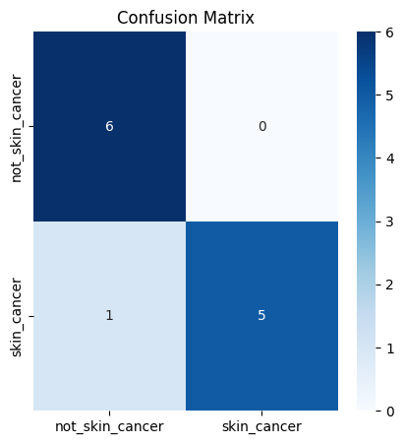

* The precision table is as follows :
* 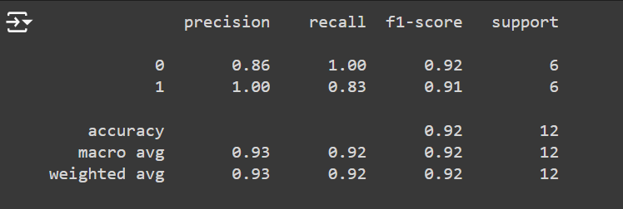
* The training loss and validation loss is as follows :
* 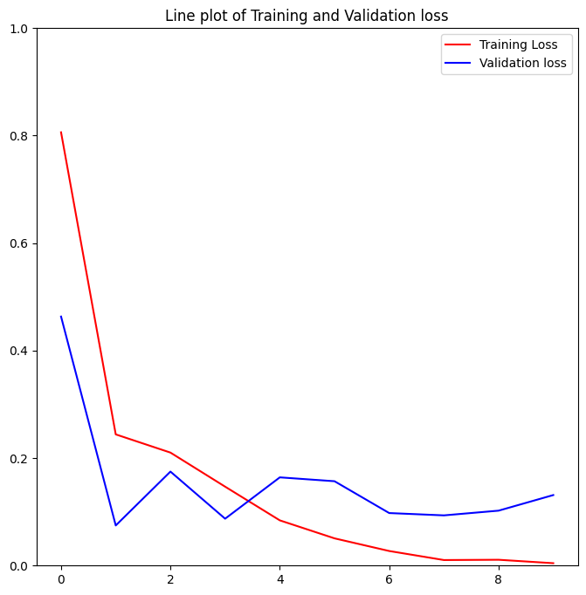
* The training and validation accuracies graph is as follows :
* 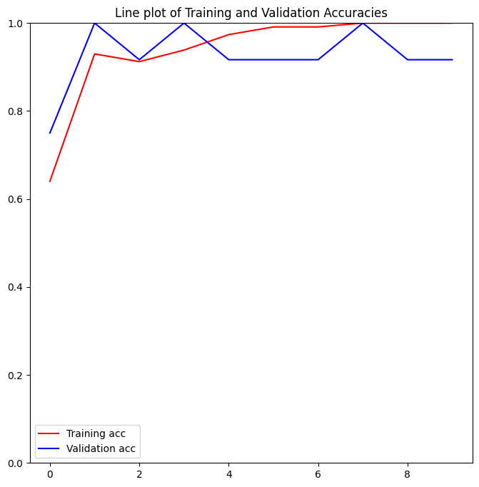
* We have attained 100% accuracy after using the MobileNetV2 model.

## *Conclusion :*

* This model can be used in detecting skin cancer and classifying it into its respective category whether it is a skin cancer or skin infection.
* Students by using the following can interpret a lot of things.
* It can be used for future references.
* It is mainly used in the medical industry.
* Accuracy plays a major role while involving in such kinds of projects by considering time management.

## *References :*

* You can read the documentation of MobileNetV2 and use it by referring to the following page : <https://keras.io/api/applications/mobilenet/>
* You can use ResNet50 model for your future work by the help of following link

Link : <https://keras.io/api/applications/resnet/#resnet50-function>

* For knowing about skin cancer , it’s classification and its types refer

<https://www.mayoclinic.org/diseases-conditions/skin-cancer/symptoms-causes/syc-20377605>